**KARNATAK UNIVERSITY**



**DHARWAD**

**Janata Shikshana Samiti’s**

**Shri Manjunatheshwara Institute of UG & PG Studies Vidyagiri, Dharwad-580004.**



**A PROJECT REPORT ON**

**“Co-Operative Society Management System”**

**BACHELOR OF COMPUTER APPLICATIONS OF KARNATAK UNIVERSITY, DHARWAD**

**PROJECT GUIDED BY**

# Mrs. Venus Mishra

## Submitted by

**PRIYANKA R. HEGDE RASHMI M. BHAT**

**BCA VI SEMESTER BCA VI SEMESTER**

**REG NO : 19U11210 REG NO : 19U11219**

**DEPARTMENT OF COMPUTER SCIENCE 2021-22**



**JANATA SHIKSHANA SAMITI’S**

**JSS SHRI MANJUNATHESHWARA INSTITUTE OF UG AND PG STUDIES VIDYAGIRI, DHARWAD-580004**

**CERTIFICATE**

**This is to certify that Ms. Priyanka R Hegde and Ms. Rashmi M Bhat has satisfactorily completed project work entitled “Co-Operative Society Management System” for the partial fulfillment of BCA by Karnatak University, Dharwad for the academic year 2021-22.**

CERTIFICATE

**Mrs. Venus Mishra Sri. Vivek M. Laxmeshwar Dr. Ajith Prasad**

Project Guide HOD Principal

Examiners Register Numbers

1. 19U11210
2. 19U11219

**ACKNOWLEDGEMENT**

**The successful presentation of this project is an acknowledgement of**

**immense support extended by JSS SMI OF UG & PG STUDIES VIDYAGIRI, DHARWAD, which has provided an opportunity to fulfil our goal.**

**We would like to express our heartfelt thanks to our** **President SHRI VISHWAPRASANNA THEERTHA OF PEJAVARMATH OF UDUPI & PUJYA DR. D VEERENDRA HEGGADE, Chairman of Janata Shikshana Samiti & Dharmadhikari of DHARMASTALA and Secretary of Janata Shikshana Samiti’s DR. N. VAJRAKUMAR.**

**We would like to express our sincere and hearty thanks of gratitude to our beloved Principal Dr. Ajith Prasad and our HOD Sri. Vivek M. Laxmeshwar who gave us the golden opportunity to do this wonderful project on the topic “Co-Operative Society Management System”, which**

**also helped us in doing a lot of research and while doing so we were exposed to a lot of new information which would help us in our mere future.**

**We would also take this opportunity to offer our sincere gratitude to our** **Project Guide Mrs. Venus Mishra for her excellent support throughout the development of this project and for providing the necessary information on our demand at all times.**

**Project Associates:**

**Rashmi M. Bhat**

**Reg No:19U11219**

**Priyanka R. Hegde**

**Reg No:19U11210**

**DECLARATION**

We Priyanka R. Hegde and Rashmi M. Bhat student of sixth semester BCA Department of Computer Science, JSS SMI UG AND PG STUDIES VIDYAGIRI, DHARWAD, KARNATAK UNIVERSITY, Dharwad declare that the project entitled “Co-Operative Society Management System” and submitted in partial fulfillment of the course, As it is requirement for the award of the degree in Bachelor of Computer Applications Karnatak University, Dharwad during the Academic Year 2021-2022.We have not submitted the matter embodied to any other university or institution for the award of any other degree.

**Date: Priyanka R. Hegde**

**Reg No:19U11210**

**Place: Dharwad Rashmi M. Bhat**

**Reg No:19U11219**

### 

**pg. 5** **JSS SMI UG & PG STUDIES,VIDYAGIRI,DHARWAD**

### CONTENTS

[**1.PROJECT SYNOPSIS ............................................................................................** 8](http://www.iibit.edu.au/project/CP800/Team%2014/Documents/SRS.htm#_Toc113964590)-11

**1.1 Introduction....................................................................................**

**2.FRAME WORK…………………………………………………………………...12-16**

**2.1 Introduction................................................................................................**

**2.2 PHP..............................................................................................................**

**2.3 HTML……………………………………………………………………..**

**2.4 MYSQL…………………………………………………………………...**

[**3.PROJECT SUBJECT ..........................................................................................**](http://www.iibit.edu.au/project/CP800/Team%2014/Documents/SRS.htm#_Toc113964590)  **16-18**

**3.1 About Project…….………………………………………………………**

**3.2 Literature Survey......................................................................................**

**3.3 Process Logic……………………………………………………………**

[4.**SYSTEM REQUIREMENTS AND SPECIFICATION………….………**](http://www.iibit.edu.au/project/CP800/Team%2014/Documents/SRS.htm#_Toc113964590)**…...**[**.**](http://www.iibit.edu.au/project/CP800/Team%2014/Documents/SRS.htm#_Toc113964590) **18-23**

**5.DATA FLOW DIAGRAM………………...…………………………………….. 23-25**

[**6.**](http://www.iibit.edu.au/project/CP800/Team%2014/Documents/SRS.htm#_Toc113964590)**ER****& USE CASE DIAGRAM**[**..............................................................................…**](http://www.iibit.edu.au/project/CP800/Team%2014/Documents/SRS.htm#_Toc113964590) **26-27**

**7.IMPLEMENTATION………………………………………………………….. 28-33**

**8.DATABASE TABLE……………………………………………………………… 34-37**

**9.SCREEN SHOT………………………………………………………………....… 38-46**

[**10.SOURCE CODE ..................................................................................................**](http://www.iibit.edu.au/project/CP800/Team%2014/Documents/SRS.htm#_Toc113964590) **47-64**

[**11.SYSTEM TESTING ...............................................................**](http://www.iibit.edu.au/project/CP800/Team%2014/Documents/SRS.htm#_Toc113964590) **64-71 11.1** [**Testing Objectives .........................................................................**](http://www.iibit.edu.au/project/CP800/Team%2014/Documents/SRS.htm#_Toc113964591)  **11.**[**2 Testing Strategies ...........................................................................**](http://www.iibit.edu.au/project/CP800/Team%2014/Documents/SRS.htm#_Toc113964591)  **11.3** [**Testing Method used ......................................................................**](http://www.iibit.edu.au/project/CP800/Team%2014/Documents/SRS.htm#_Toc113964591)  **11.4** [**Test Cases & Results ......................................................................**](http://www.iibit.edu.au/project/CP800/Team%2014/Documents/SRS.htm#_Toc113964591)

1. **CONCLUSION****…**[**.................................................................................................**](http://www.iibit.edu.au/project/CP800/Team%2014/Documents/SRS.htm#_Toc113964590) **71-72**

[**13.FUTURE**](http://www.iibit.edu.au/project/CP800/Team%2014/Documents/SRS.htm#_Toc113964590) **SCOPE** [**......................................................................................................**](http://www.iibit.edu.au/project/CP800/Team%2014/Documents/SRS.htm#_Toc113964590) **72**

**14.** [**BIBLIOGRAPHY ....................................................................................................**](http://www.iibit.edu.au/project/CP800/Team%2014/Documents/SRS.htm#_Toc113964590) **73**

# SYNOPSIS

Introduction

It is easy to maintain and review record details about the Co-Operative Society, analytics on insights of sales. It aides in assigning the task to all the department work members. Maintain the account detail about the expenditure and also total number of products and services in the system database. It provides billing and online ordering facility to the end users.

Objectives

* To manage the details of grocery and veterinary product.
* To provide the searching facility based on various factors such as   
   products, sales, purchases.
* To provide an interface to the customers.
* To manage online ordering.
* To manage the customer details.
* To handle the billing system.
* To provide secure system.

Input

* Farmer information
* Product information
* Customer information
* Sales information

Output

* Sales report
* Purchase report
* Customer report
* Invoice report
* Graphical Representation of Sales

Process Logic

Input Output

Farmer information

Product information

Customer information

Purchase information

Sales information

Farmer payment report

Sales report

Customer report

Purchase report

Invoice report

Graphical representation

### Data Flow Diagram:(Zero level)

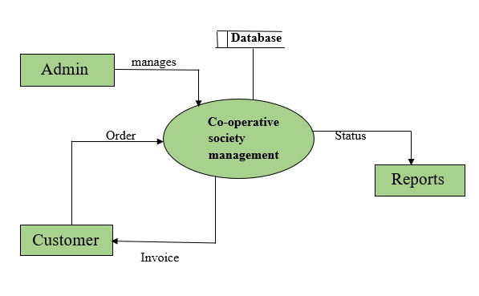

Tools/Platforms, Languages to be used

Hardware requirements

|  |  |
| --- | --- |
| Processor | Core i3 intel processor |
| RAM | 1GB and more |
| Hard Disk | 20 GB of available space in hard disk |
| Operating System | Windows 7 or higher |

Software/language Requirements

* Front End : Html, CSS
* Middleware : PHP
* Scripting : Java script
* Backend : MYSQL
* Server : Xampp Server

Duration of the Project

* 2 Months

Members of the Project

Two

* Priyanka R. Hegde (19U11210)
* Rashmi M. Bhat (19U11219)

Limitations of the Project

* Live tracking of order is not possible.
* Bar code scanning is not provided.

Scope or Future application

* mobile application can be developed.
* bar code scanning can be provided.
* Home delivery can be provided.

Are you doing this Project for any industry/ Client? If yes, acceptance of the Project

* Yes

Client : Co-operative Society

### FRAMEWORK

**Introduction to technologies used in this project:**

Implementation is the realization of an application, or execution of a plan, idea, model, design, specification, standard, algorithm, or policy and it is a process of having the systems personnel check out and put new products into use and construct any files of data needed to use it.

**Why you need XAMPP, MySQL and PHP?**

PHP is a powerful scripting language that can be run by itself in the command line of any computer with PHP installed. However, PHP alone is not enough in order to build dynamic web sites. To use PHP on a web site, you need a server that can process PHP scripts. WAMP server allows developers to test PHP scripts locally. Additionally dynamic websites are dependent on stored information that can be accessed easily; this is the main difference between a dynamic site and a static HTML site. However, PHP does not provide a simple, efficient way to store data. This is where a relational database management system like MySQL comes into play.

**Introduction to PHP:**

PHP is a scripting language originally designed for producing dynamic web pages. It has evolved to include a command line interface capability and can be used in standalone graphical application. While PHP was originally created by RasmusLerdorf in 1995, the main implementation of PHP is now produced by the PHP Groups and serves as the de facto standard for PHP as there is no formal specification.

PHP is a scripting language under the PHP License; however, it is incompatible with the GNU General Public License (GPL). due to restrictions on the usage of the term PHP. It is widely-used general-purpose scripting language that is especially suited for web development and can be embedded into HTML. It generally runs on a web server, taking PHP code as its input I am creating web pages as out puts. It can be deployed on web servers and on almost every operating system and platform free of charge. PHP is installed on more than twenty million web sites and one million web servers. PHP usually should for personal home page.

**HTML**

HTML means Hypertext Markup Language. HTML is a method of describing the format of document, which allows them to be viewed on computer screen. Web browsers display HTML documents, program which can navigate across networks and display a wide variety of types of information. HTML pages can be developed to be simple text or to be complex multimedia extra advantages containing, moving images, virtual reality, and java applets.

Hypertext Markup language (HTML) is used to creating the web page either of static or dynamic and used to develop the user-friendly web pages.

HTML is used for developing web pages .HTML is popularly used in world wide web (WWW). It uses ASCII characters for both the main text and formatting instructions the main text is data and the hole information is used by the browser to format the data. A HTML document is simply a text file, which contains certain information you would like to publish.

A set of instruction embedded in a document is called Markup Language. These instructions describe what the document text means and how it should look in a display. The language also tells you how to make a document with other document on your local systems. The World Wide Web and other inter resources such as FTP.

The global publishing format of the Internet is HTML. It allows authors to use not only text but also format that text with headings, list and tables, and also includes still images videos, and sound within text. Readers can access pages information from anywhere in the world at the click of mouse button information can be downloaded to readers own PC or workstations HTML pages can also be used for entering a data and as a front end for commercial transaction.

**Usage:**

PHP is a general-purpose scripting language that is especially suited for web development. PHP generally runs on a web server, taking PHP code as its input and creating web pages as output. It can also be used for command-line scripting and client-side GUI applications. PHP can be deployed on most web servers, many operating systems and platforms, and can be used with many relational database management systems. It is available free of charge, and the PHP Group provides the complete source code for users to build, customize and extend for their own use.

PHP primarily acts as a filter, taking input from a file or stream containing text and/or PHP instructions and outputs another stream of data; most commonly the output will be HTML. It can automatically detect the language of the user. From PHP 4, the PHP parser compiles input to produce byte code for processing by the Zend Engine, giving improved performance over its interpreter predecessor. Originally designed to create dynamic web pages, PHP’s principal focus is server-side scripting, and it is similar to other server-side scripting languages that provide dynamic content from a web server to a client, such as Microsoft’s Active Server Pages, Sun Microsystems’ Java Server Pages, and mod_perl. PHP has also attracted the development of many frameworks that provide building blocks and a design structure to promote rapid application development (RAD). Some of these include CakePHP, Symfony, CodeIgniter, and Zend Framework, offering features similar to other web application frameworks.

The WAMP architecture has become popular in the web industry as a way of deploying web applications. PHP is commonly used as the PHP in this bundle alongside Linux, Apache and MySQL, although they may also refer to Python or Perl. As of April 2007, over 20 million Internet domains were hosted on servers with PHP installed, and PHP was recorded as the most popular Apache module. Significant websites are written in PHP including the user-facing portion of Facebook, Wikipedia (MediaWiki), Yahoo!, MyYearbook, Digg, WordPress and Tagged.

In addition to server-side scripting, PHP can be used to create stand-alone, compiled applications and libraries, it can be used for shell scripting, and the PHP binaries can be called from the command line.

**MY SQL:**

What is data base?

Quite simply, It’s an organised collection of data. A data base management system (DBMS) such as access file maker pro, oracle or SQL server provides you with the software tools you needed to organize that data in a flexible manner. It includes facilities to add modify or delete data from data base, ask questions (or queries) about the data stored in the data base and produce reports summarizing selected contents.

My SQL is a multithreaded, multi-user SQL database management system(DBMS).The basic program runs as a server providing multi-user access to a number of data bases originally Financing in a singular fashion to the JBoss model ,My SQL was owned and sponsored by a single for-profit firm the Sidish company MY SQL now a subsidiary of Sun Micro System, which hold the copy write to most of the database .The project source code is available under terms of the GNU(General Public License),as ill as a under a variety of proprietary agreements. My SQL is a database. The data in My SQL is stored in database objects called Tables. A table is a collection of related data entries and consist of columns and rows. Databases are useful when storing information categorically.

**FEATURES OF MySQL:**

* It is simple English like language and uses simple commands such as SELECT, CREATE, DROP etc.
* It is not having condition loops, variables and most of the commands are single line commands.
* To implement application logics, SQL has got extension language popularly called as PL/SQL (Procedural language of sql).
* One of the key features of sql server is the XML support. XML has

Grown to be standard technology for organizations that share data on the web.

* Now with sql server 2000 XML documents can be retrieved directly from the database and it provides various ways to retrieve data in XML format.
* The entire SQL has been divided into 4 major categories.

1. Data Manipulation Language.

2. Data Definition Language.

3. Transaction Control language.

4. Data Control Language.

**HARDWARE SPECIFICATION:**

|  |  |
| --- | --- |
| Processor | Core i3 intel processor |
| RAM | 1GB and more |
| Hard Disk | 20 GB of available space of hard disk |
| Operating System | Windows 7 or higher |

**SOFTWARE SPECIFICATION:**

**FRONT END:** HTML, CSS

**OPERATING SYSTEM:** WINDOWS 7 and above

**SERVER-SIDE SOFTWARE:** XAMPP server

**MIDLEWARE:**PHP

**SCRIPTING**: JavaScript

**DATABASE:** MySQL

**DESINING TOOL:** Dreamweaver

### PROJECT SUBJECT

It is easy to maintain and review record details about the Co-Operative Society, analytics on insights of sales. It aides in assigning the task to all the department work members. Maintain the account detail about the expenditure and also total number of products and services in the system database. It provides billing and online ordering facility to the end users

**SYSTEM REQUIREMENT & ANALYSIS**

**SYSTEM REQUIREMENTS:**

System specification forms the foundation on which the architecture, design, and implementation of a software is built. Documents containing system specifications are critical because major expenses come along with having to fix the implementation of incorrect requirements as a result of not having a specification document on hand. System specification documents can thus be defined as the requirements documentation that formally specifies the system-level requirements of a software application.

System specification documents most predominantly contain information on basic website requirements which include:

* Performance levels
* Reliability
* Quality
* Interfaces
* Security and privacy
* Constraints and limitations
* Functional capabilities
* Data structures and elements

**Analysis**

**Requirement Analysis**

I have collected the information about the existing system and their service deals and information, and found that the hole process of maintaining details is done manually. I have gathered information of the appointment, products maintenance, services and their responsibilities limitations etc.

**Reviewing the analysis document:**

By reviewing the analysis document, I have decided to develop a web application and planned to do it in the specified time

I have analysed the co-operative society responsibility and gave them the particular rights like keeping track of information.

**Designing the interface:**

I have designed the module interface form using HTML.

**Implementing the ideas:**

According to the requirement stated by the organization I coded the forms and used the HTML for the web pages and finally designed the web applications to run in XAMPP Server because of open source and I have used MySQL as Back End because of its better security.

**Validation:**

I have tested the modules with different values and the testing stage and rectified some minor flaws in the update code of PHP.

Finally, I have generated the reports and finalised the project and approached the organization with the prototype and confirmed that the requirements are met.

**SOFTWARE REQUIREMENT SPECIFICATION**

**OVERVIEW OF SRS:**

The software requirement specification is developed to address the user requirement for the development of software this document provides purpose scope functional and non-functional requirements of “co-operative society” it also specifies user interface performance etc, using Dreamweaver to develop the system.

**Scope:**

* This project can be used not only as the information system but as the management system also only by including some more management features and modifications.
* This project can also be made to work online by providing the internet features and hence can be changed to work as an online job portal
* In future android application can be developed.

**Purpose:**

* This project proposing desktop application as well as website.
* Manages the customers in a better way
* Easy to find the various information related to co-op society.
* Maintains the date of purchasing and selling.
* Administrator will get accurate details about products, sales and customers.
* Provides online ordering.

**Definitions, Acronyms and Abbreviations**

GUI: Graphical User Interface

HTML: Hypertext Markup Language. Is the predominant markup language for Webpages

HTTP – Hyper Text Transfer Protocol

**Overview:**

* Design the proposed system
* Implementing the system.
* Installing the software.
* Testing the system for compliances.
* Maintaining the system.
* Perform validation and rectify error if any.

**Functional Requirements:**

Functional requirements are statements of the services of the services that the system must provide or are description of how some computations must be carried out. The plan for implementing functional requirements is detailed in the system design

* Admin is provided with Username and Password to avoid unauthorized access.
* Basic and advance admin facilities like add/update/delete are provided.
* Manages customers details.
* Manages selling and purchasing of products
* Back up/ recovery of data is available.
* Role based System functions access

**Non- Functional Requirements**

A non-functional requirement is a requirement that specifies criteria that can be used to judge the operation of a system, rather than specific behaviours. This should be contrasted with functional requirements that specific behaviour or functions. The plan for implementing non-functional requirements is detailed in the system architecture.

* The application is available from several locations and it accessible 24*7 with the help of internet.
* The code is easily understood and read because of the structure and coding style of the application.
* Various components are provided in order to improve the performance at peak time.

**User Interface:**

The user interface allows the users to remotely access the system via several applications Users will be able to use the service through applications such as Mozilla Firefox, Microsoft Internet Explorer, google chrome etc. Allow the user to access the information fast and easily from remote locations

* Compatibility

The software is compatible with windows 7 higher. It requires Microsoft Internet Explorer 5.0 or above with server.

* Portability

The software is extremely portable in the sense that it can be run on any machine with Web-browser.

* Acceptance criteria

The system must work well and compile with all the requirements and constraints stated above. All condition defined by the need user by the end user are to be satisfied. The system should satisfy all the requirement and constraints of the forest department Management System and must work well according to necessity.

**Design constraints:**

In case of any error handling mechanisms have been provided

* Without proper authorization the data in the data base can’t be modified.
* Complete validation has been done so that no mandatory fields are empty by chance if any field is left empty then appropriate alert message will be displayed.
* In case of any errors Error handling mechanism have been provided

**SPIRAL MODEL**

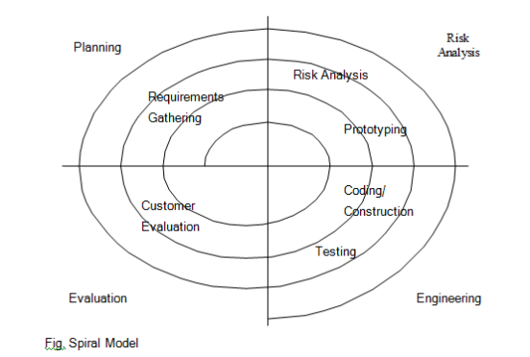

The spiral model is similar to the incremental model with more emphasis placed on risk analysis. The spiral model has four phases: Planning, Risk Analysis, Engineering and Evaluation. A software project repeatedly passes through these phases in iterations (called Spirals in this model). The baseline spirals, starting in the planning phase, requirements are gathered and risk is assessed. Each subsequent spirals builds on the baseline spiral. It’s one of the [**software development models**](http://istqbexamcertification.com/what-are-the-software-development-models/).

**Planning Phase:**Requirements are gathered during the planning phase. Requirements like

**Object-oriented Analysis& Design**

**Object-oriented Analysis Design**

Object-oriented analysis and design (OOAD) is software engineering approach that models a system as a group of interacting objects. Each object represents some entity of interest in the system being modelled, and is characterized by its class, its state (data elements), and its behaviour.

Various modules can be created to show the static structure, dynamic behaviour, and run-time deployment of these collaborating objects. There are number of different notations for representing these models such as the unified Modelling Language (UML)

Object- oriented analysis (OOA) applies object-modelling techniques to analyse the functional requirements for a system. Object-oriented design (OOD) elaborates the analysis models to produce implementation specifications. OOA focuses on what the does, OOD on how the system does it.

**Design of the System:**

**Introduction:**

The purpose of the design phase is to plain a solution of the problem specified by the requirements documents. This phase is the first step moving the problem domain to the solution domain. It involves the step moving the problem domain to the solution domain it involves the process, in which conceiving, planning and the carrying out the plain by generating the necessary report and inputs, in other words, the design phase act as a bridge between SRS and implementation phase. The design of the system is perhaps the most critical factor affecting the quality of the software, and has a major impact on the later phase, particularly the testing and maintenance.

**Design System:**

System design concerned with how the system functionality is to be provided by the different components of the system Design is the key phase of any project. It is the first step in moving from problem domain to the solution domain. It may be defined as “The process of applying various techniques and principles for the purpose of defining device, a process, or a system insufficient detail to permit its physical realization”. The input to design phase is the specifications of the system to be designed. The output of the top-level design is the architectural design, or the system design for the software system to be built. A design should be very clear, verifiable, complete, traceable, efficient and simple.

**SYSTEM DESIGN**

**Data Flow Diagram:**

The data flow diagram (DFD) is one of the important modelling tools. It shows the user of the data pictorially. DFD represents the flow of data between different transformations and processes in the system. The data flow diagram shows logical flow of the data. It represents the functional dependencies within a system. It shows output values in a computation are derived from input values. It is simple pictorial representation or model for system behaviour. It specifies, “What is to be done but not how is to be done”. It describes the logical structure of the system. It relates data information to various processes of the system. It follows top-down approach.

**Data Flow Diagram Notations:**

**Data Flow:**

It may be from file-to-file or file-to-process or process-to-process.It is generally in terms of attributes.There may be either an input data flow or output data flow.

**Functional processing:**



The process is nothing but the transformation of data. It starts with the subject and

has the verb followed by the subject.

**Data store:**



It includes file, data base and repository. To parallel lines represent it or a one end closed rectangle.

**Actor/source/sink:**

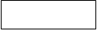

The files which are outside the system and used by the process or processes of the system. Generally, Source/sink in the actor.

**Objectives:**

* To graphically document boundaries of a system.
* To provide hierarchy breakdown of the system.
* To show movement of information between a system and its environment.
* To document information flows within the system.
* To aid communication between users and developers.

**ZERO LEVEL DATA FLOW DIAGRAM**



**ONE LEVEL DATA FLOW DIAGRAM**

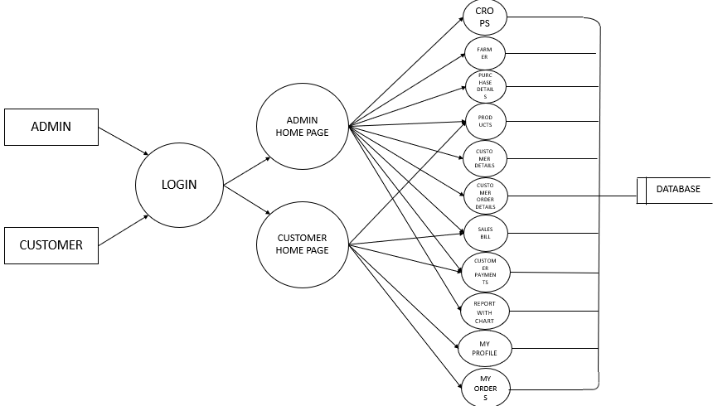

## ER diagram

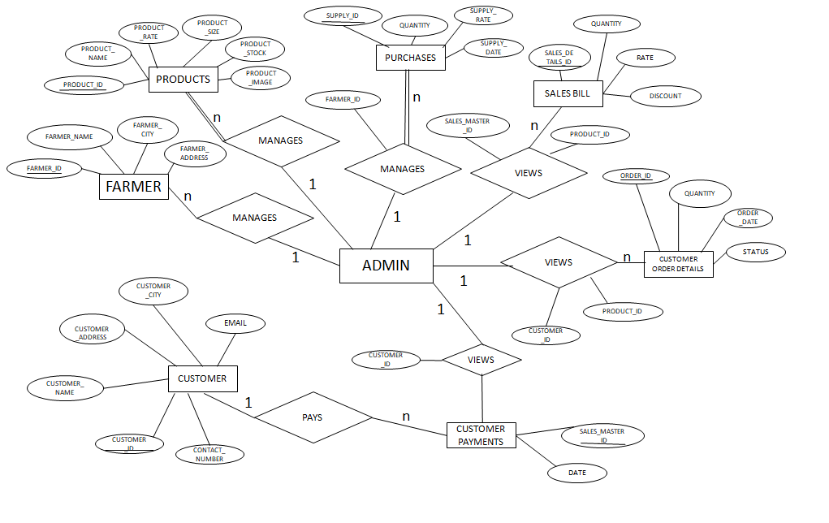

**USE-CASE DIAGRAM**

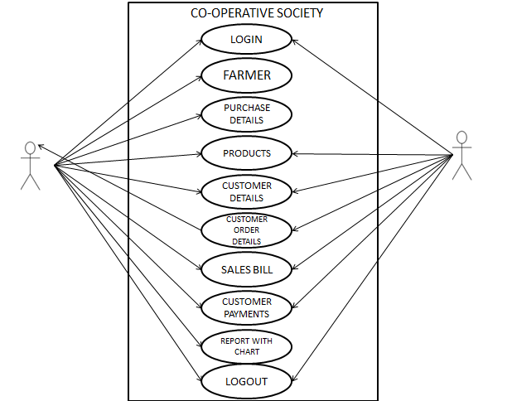

CUSTOMER

ADMIN

## IMPLEMENTATION

## Introduction:

Implementation is the process of converting a new revised system design into operation. The objective is to put the new revised system, which has been tested into operation while holding costs, risks and personal irritation to the minimum. A critical aspect of the implementation process is to ensure that there will be no description in the function of the organization. The best methods for going control while implementation any new system would be to use well planned test files for testing all new programs. Another factor to be convinced in the implementation phase in the acquisition of the hardware and software. Once the software is developed for the system and testing is carried out, it is the process of making the newly designed system fully operational and consistent in performance.

**Example**

**<?php**

**Echo “WELCOME TO OUR PROJECT”**

**/?>**

### Speed optimization

As with many scripting languages, PHP scripts are normally kept ashuman-readable source code, even on production web servers. In this case, PHP scripts will be compiled at runtime by the PHP engine, which increases their execution time. PHP scripts are able to be compiled before runtime using PHP compilers as with other programming languages such as C (the language PHP and its extensions are written in). Code optimizers aim to reduce the computational complexity of the compiled code by reducing its size and making other changes that can reduce the execution time with the overall goal of improving performance. The nature of the PHP compiler is such that there are often opportunities for code optimization, and an example of a code optimizer is the Zend Optimizer PHP extension.

Another approach for reducing overhead for high load PHP servers is using PHP accelerators. These can offer significant performance gains by caching the compiled form of a PHP script in shared memory to avoid the overhead of parsing and compiling the code every time the script runs.

**Example to display message using HTML page:**

<!DOCTYPE HTML PUBLIC "-//W3C//DTD HTML 4.01 Transitional//EN"

"http://www.w3.org/TR/html4/loose.dtd">

<html>

<head>

<meta http-equiv="Content-Type" content="text/html; charset=iso-8859-1">

<title>Untitled Document</title>

</head>

<body>

<h1>WELCOME TO OUR PROJECT</h1>

</body>

</html>

Output:

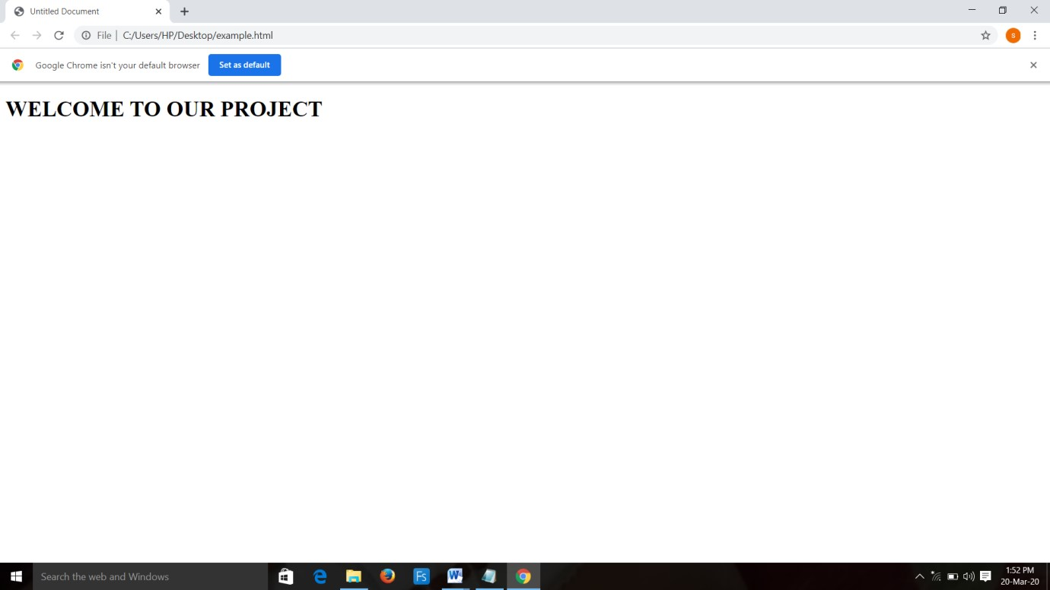

**Steps to create a database in PHPMyAdmin:**

1) The following figure shows your PHPMyAdmin interface, just enter your database name and click the 'Create' button to create your database.

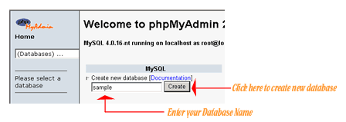

2) Now to create a new table enter your table name and the number of fields in the table, then click the 'Go' Button.

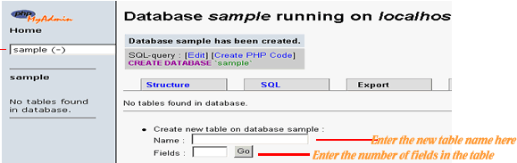

3) The next step is to create the fields, just enter values for each field name, type, length of the field, null option and mention whether it is a primary key or not. Then click the 'Save' button to complete your table creation.

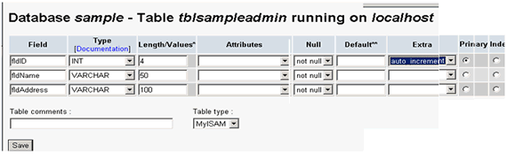

4) The following figure is displayed upon successful creation of your table

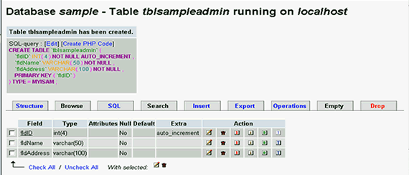

**2. Steps to Drop Table in PHPMyAdmin**

Login to phpMyAdmin. Click 'databases'

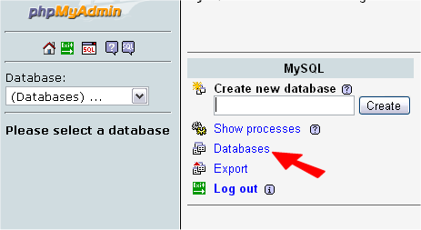

A list of your databases will appear. Click the one that is your WordPress database.

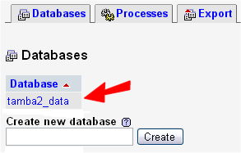

Note the size of the 'wp_bad_behaviour_log' table - this is one to be emptied in this example.

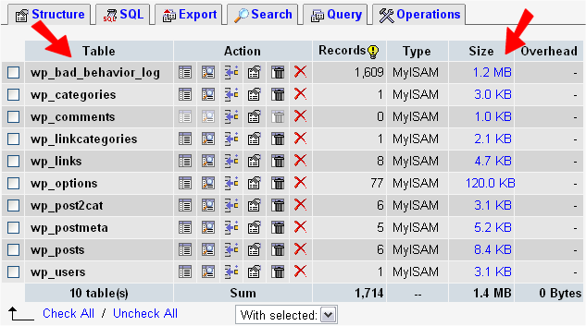

Now tick the box to the left of the table you wish to empty.  
Note: your table may well have a different name, and unless you have been told otherwise, do NOT empty a table that is used by the Word Press core.

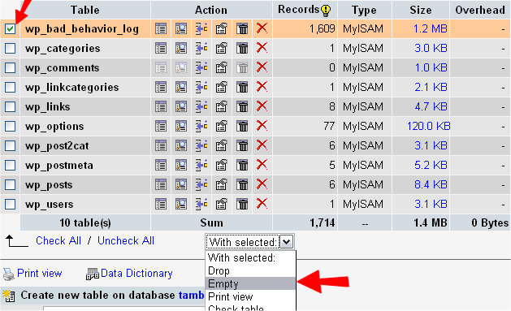

From the drop-down menu, highlight and click the 'Empty' option. You will now get a conformation message This is your last chance to check - there is no 'UNDO' function here!

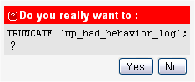

Click 'Yes' and you will be returned to viewing all the tables in your install.

### TABLES USED IN DATABASE

Crops

|  |  |  |  |  |
| --- | --- | --- | --- | --- |
| **Column Name** | **Data Type** | **Size** | **Constraints** | **Key** |
| crop_id | Integer | 100 | Not null | Primary key |
| crop_name | Varchar | 150 | Not null |  |
| crop_description | Varchar | 500 | Not null |  |

Customer details

|  |  |  |  |  |
| --- | --- | --- | --- | --- |
| **Column Name** | **Data Type** | **Size** | **Constraints** | **Key** |
| customer_id | Integer | 90 | Not null | Primary key |
| customer_name | Varchar | 100 | Not null |  |
| customer_address | Varchar | 250 | Not null |  |
| customer_city | Varchar | 250 | Not Null |  |
| contact_number | Varchar | 10 | Not Null |  |
| email | Varchar | 100 | Not Null |  |

products

|  |  |  |  |  |
| --- | --- | --- | --- | --- |
| **Column Name** | **Data Type** | **Size** | **Constraints** | **Key** |
| product_id | Integer | 100 | Not null | Primary key |
| product_name | Varchar | 150 | Not null |  |
| product_rate | Integer | 200 | Not null |  |
| product_size | Varchar | 100 | Not Null |  |
| product_stock | Varchar | 100 | Not Null |  |
| product_image | Varchar | 200 | Not Null |  |

Customer order details

|  |  |  |  |  |
| --- | --- | --- | --- | --- |
| **Column Name** | **Data Type** | **Size** | **Constraints** | **Key** |
| order_id | Integer | 11 | Not null | Primary key |
| customer_id | Integer | 11 | Not null | Foreign key |
| product_id | Integer | 11 | Not null | Foreign key |
| quantity | Integer | 11 | Not Null |  |
| order_date | date |  | Not Null |  |
| status | Varchar | 60 | Not Null |  |

Customer payments

|  |  |  |  |  |
| --- | --- | --- | --- | --- |
| **Column Name** | **Data Type** | **Size** | **Constraints** | **Key** |
| Customer_payment_id | Integer | 90 | Not null | Primary key |
| customer_id | Integer | 11 | Not null | Foreign key |
| payment_amount | Integer | 110 | Not null |  |
| description | varchar | 250 | Not Null |  |
| payment_date | date |  | Not Null |  |

Farmer

|  |  |  |  |  |
| --- | --- | --- | --- | --- |
| **Column Name** | **Data Type** | **Size** | **Constraints** | **Key** |
| farmer_id | Integer | 100 | Not null | Primary key |
| farmer_name | varchar | 150 | Not null |  |
| farmer_city | varchar | 170 | Not null |  |
| farmer_address | varchar | 200 | Not Null |  |

login

|  |  |  |  |  |
| --- | --- | --- | --- | --- |
| **Column Name** | **Data Type** | **Size** | **Constraints** | **Key** |
| User_name | Varchar | 100 | Not null |  |
| password | Varchar | 20 | Not null |  |
| type | Varchar | 20 | Not null |  |
| security_ques | Varchar | 200 | Not Null |  |
| security_ans | Varchar | 200 | Not Null |  |
| status | Varchar | 100 | Not Null |  |

Sales master

|  |  |  |  |  |
| --- | --- | --- | --- | --- |
| **Column Name** | **Data Type** | **Size** | **Constraints** | **Key** |
| Sales_master_id | Integer | 140 | Not null | Primary key |
| date | Date |  | Not null |  |
| Customer_id | Integer | 11 | Not null | Foreign key |

Sales details

|  |  |  |  |  |
| --- | --- | --- | --- | --- |
| **Column Name** | **Data Type** | **Size** | **Constraints** | **Key** |
| Sales_details_id | Integer | 100 | Not null | Primary key |
| Sales_master_id | Varchar | 150 | Not null | Foreign key |
| Product_id | Integer | 200 | Not null | Foreign key |
| quantity | Integer | 180 | Not Null |  |
| rate | Integer | 11 | Not Null |  |
| discount | Varchar | 250 | Not Null |  |

Supply details

|  |  |  |  |  |
| --- | --- | --- | --- | --- |
| **Column Name** | **Data Type** | **Size** | **Constraints** | **Key** |
| supply_id | Integer | 90 | Not null | Primary key |
| farmer_id | Varchar | 100 | Not null | Foreign key |
| sugarcane_id | Integer | 120 | Not null |  |
| quantity | Integer | 150 | Not Null |  |
| supply_rate | Integer | 11 | Not Null |  |
| supply_date | date |  | Not Null |  |

SCREEN SHOTS

**1.HOMEPAGE**

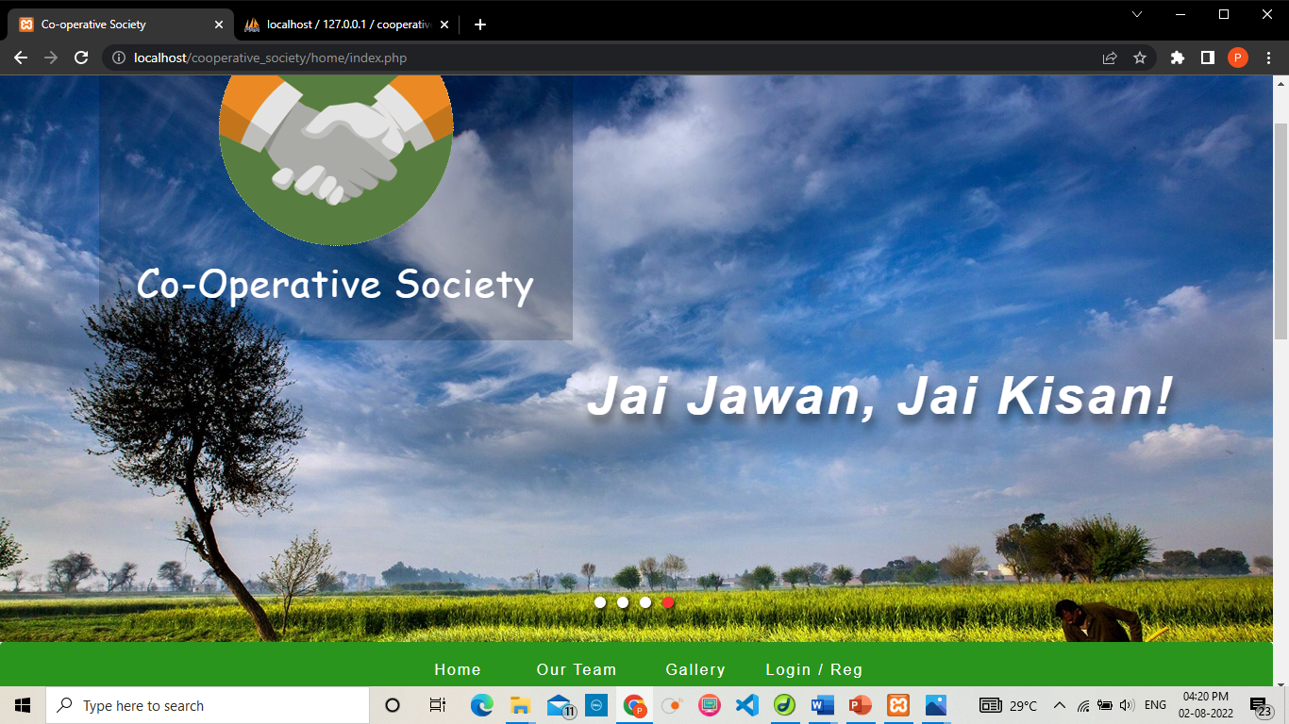

**2.LOGIN PAGE:**

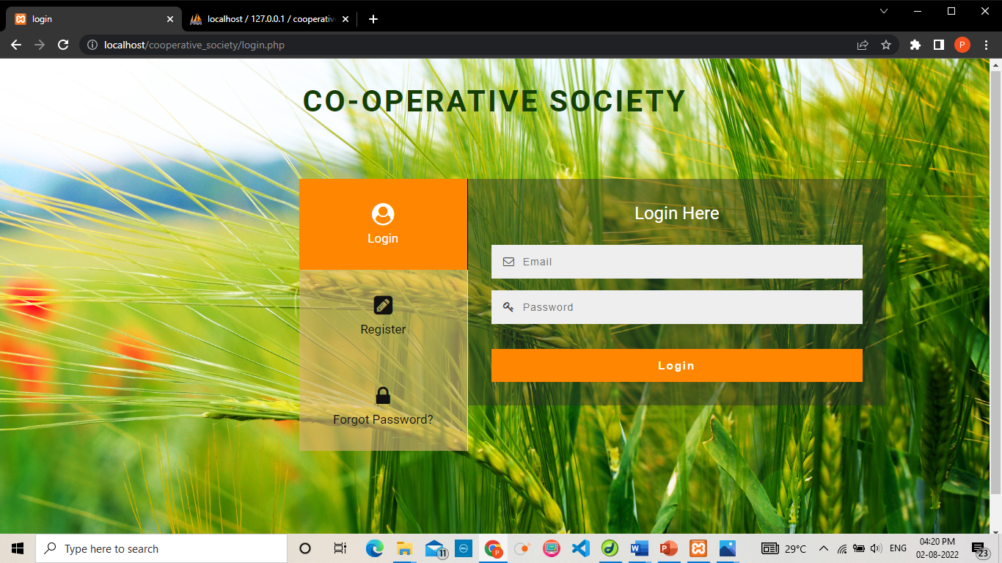

**3.INVALID LOGIN:**

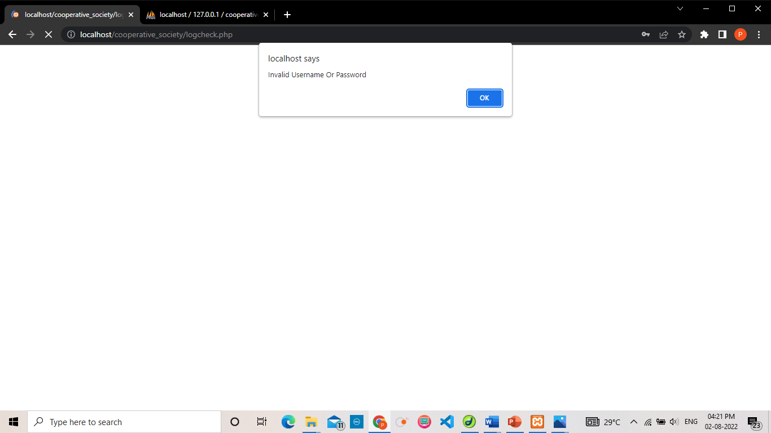

**4.REGISTATION FORM:**

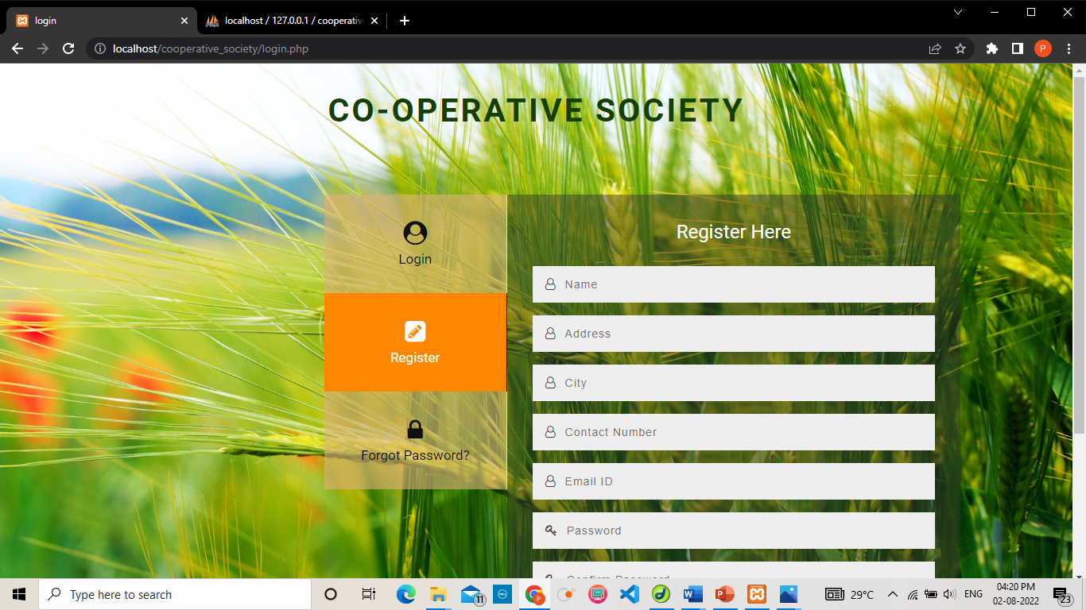

**5.REGISTATION SUCCESSFUL:**

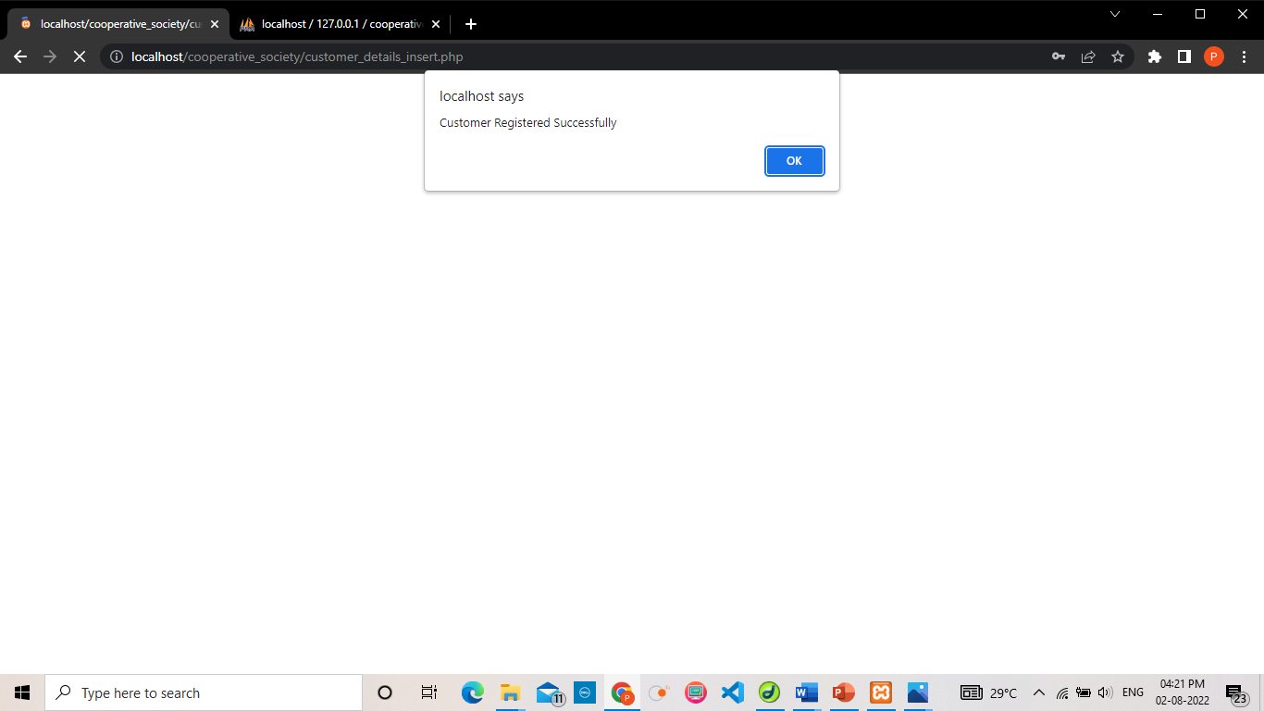

**6.FORGOT PASSWORD:**

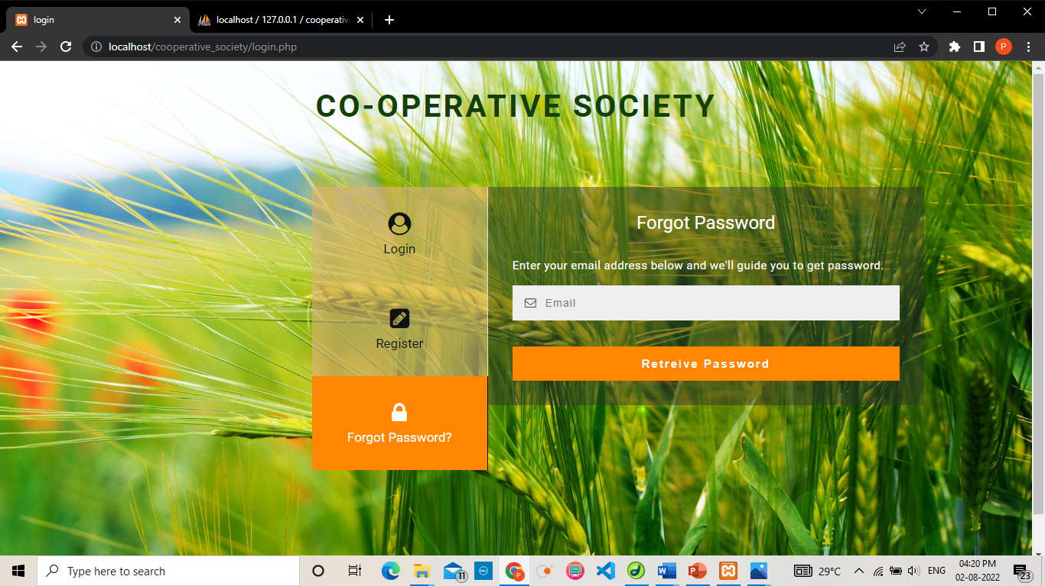

**7.ADMIN PAGE**

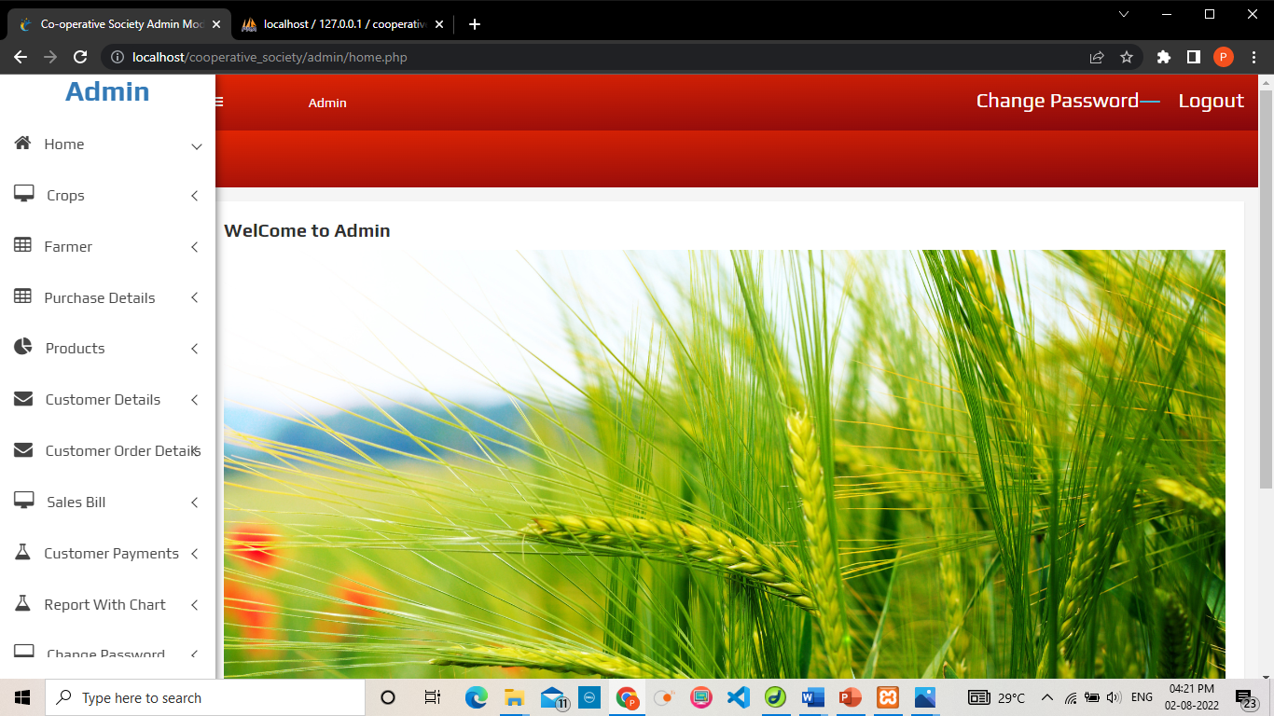

**8.CUSTOMER ORDER DETAILS TABLE VIEW:**

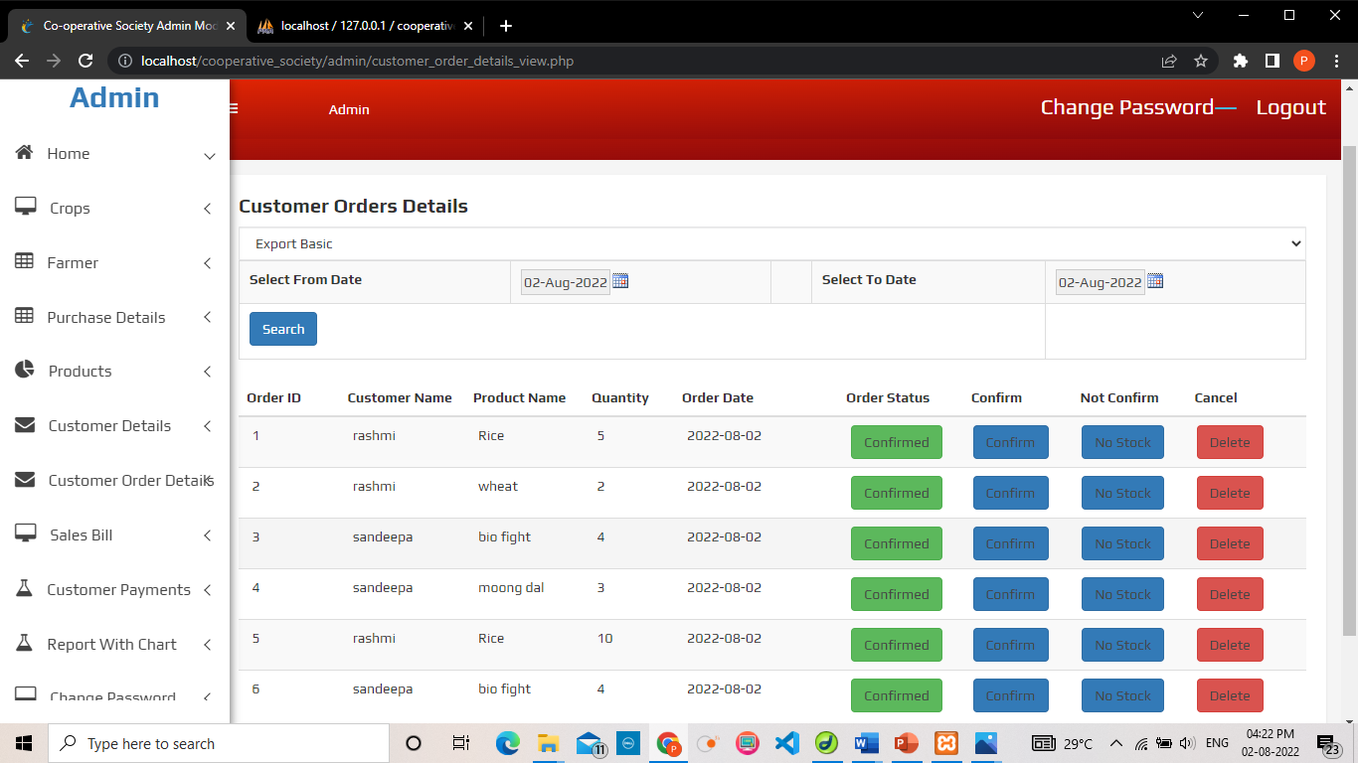

**9.CROP DETAILS:**

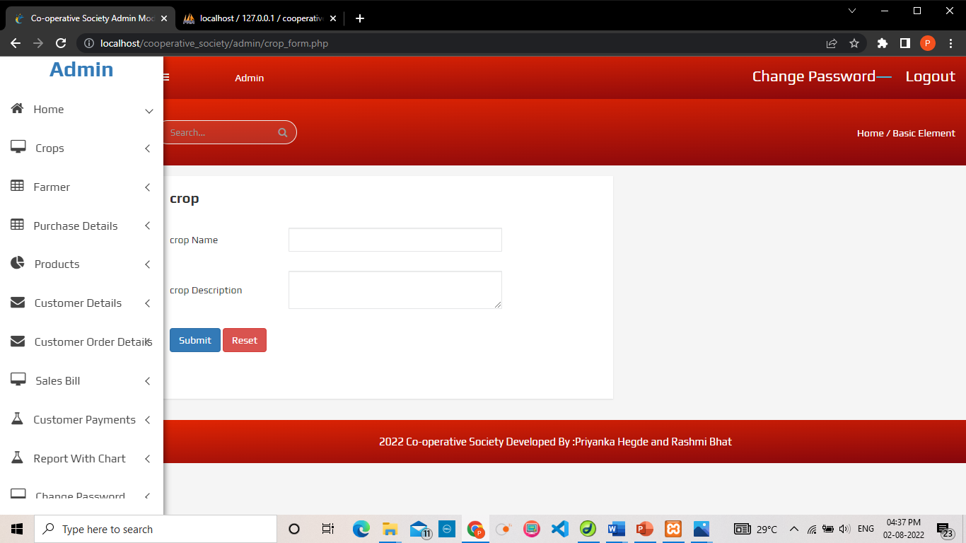

**10.EDIT TABLE**

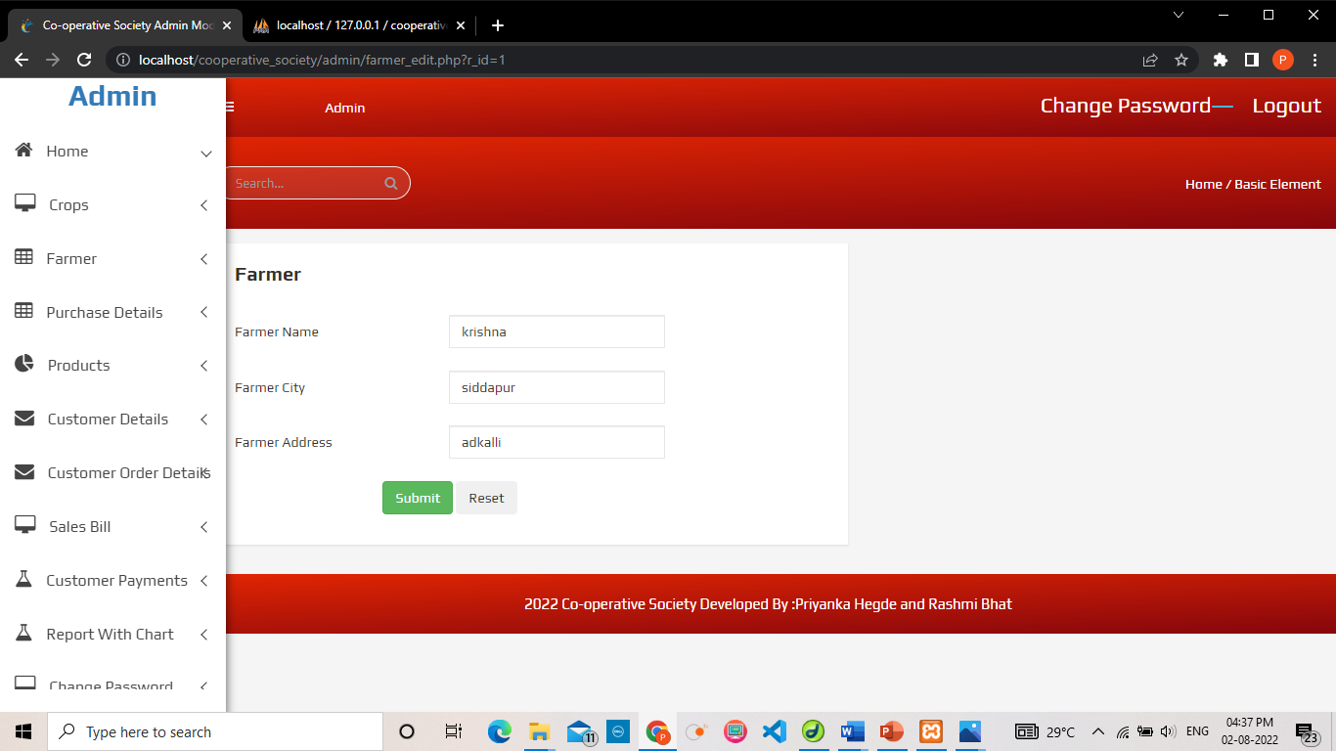

**11.RECORD DELETED:**

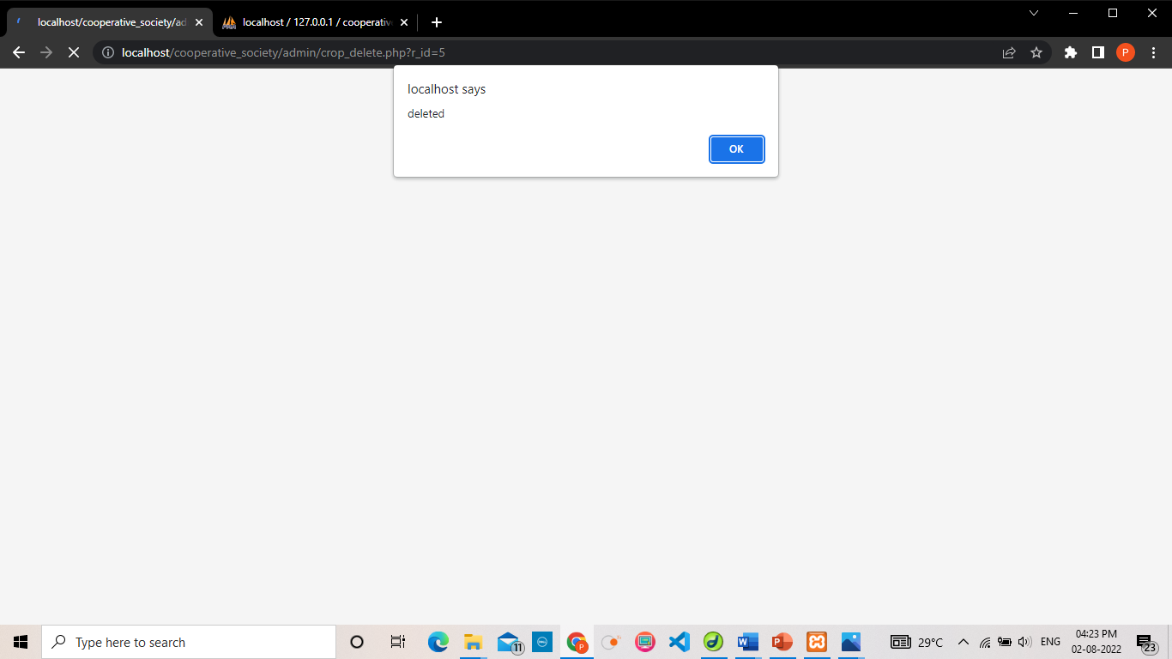

**12.SALES REPORT USING CHART:**

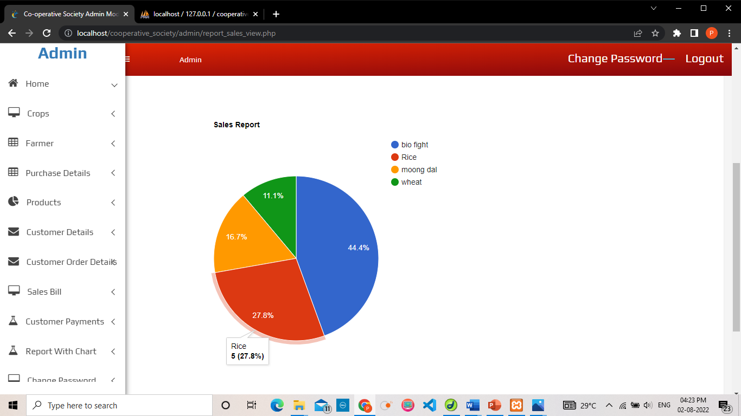

**13.CHANGE PASSWORD:**

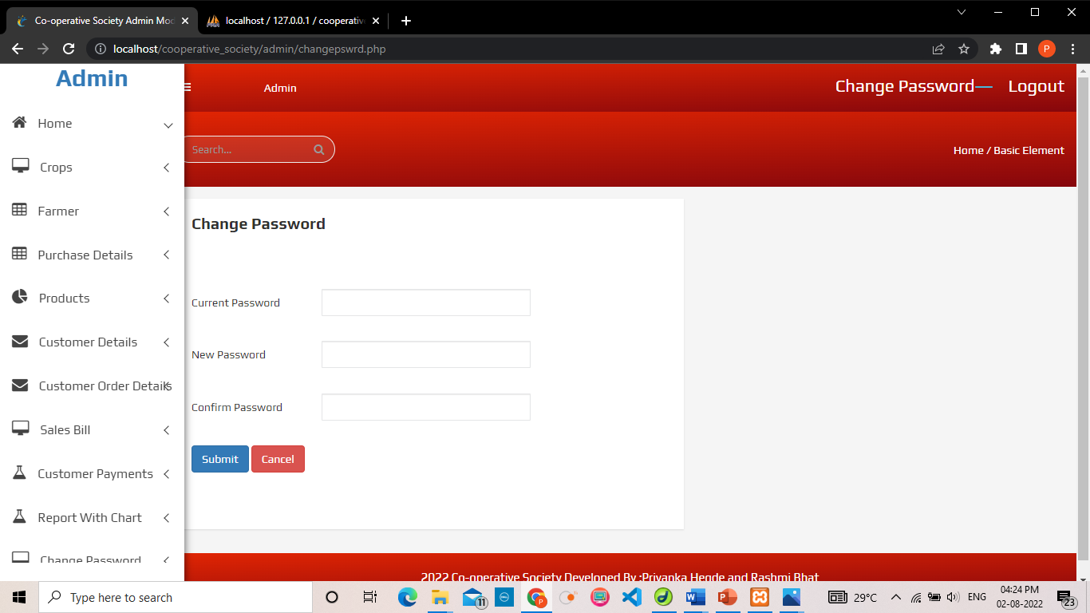

**14.VALIDATION:**

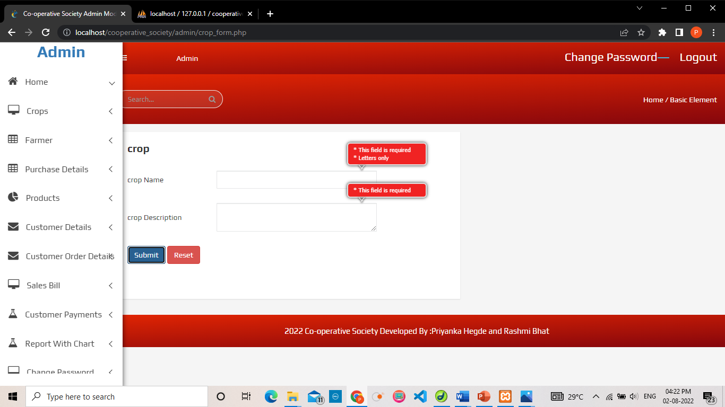

**15.INSERT:**

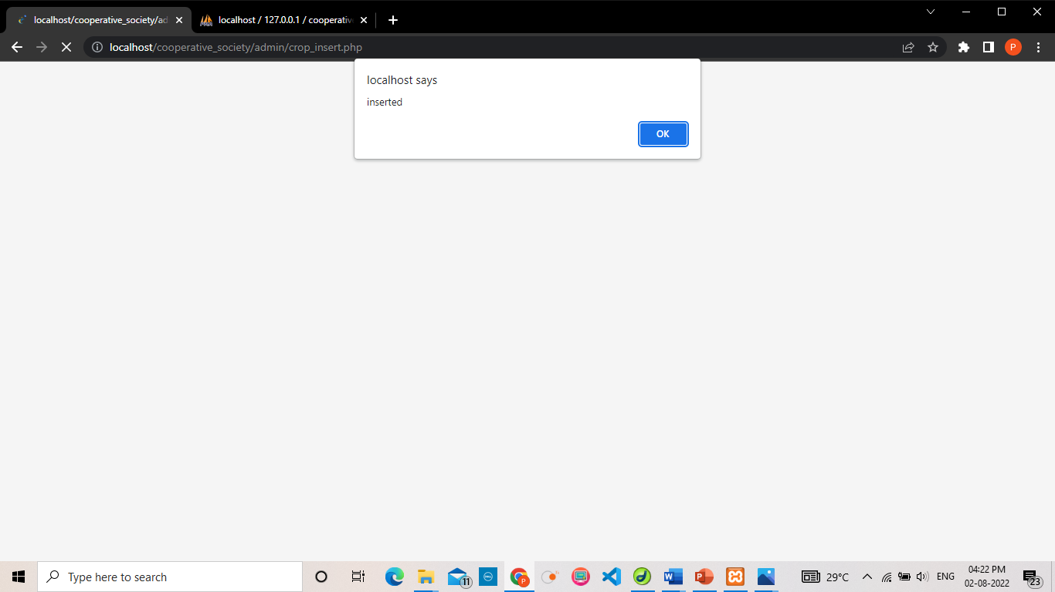

**16.LOGOUT:**

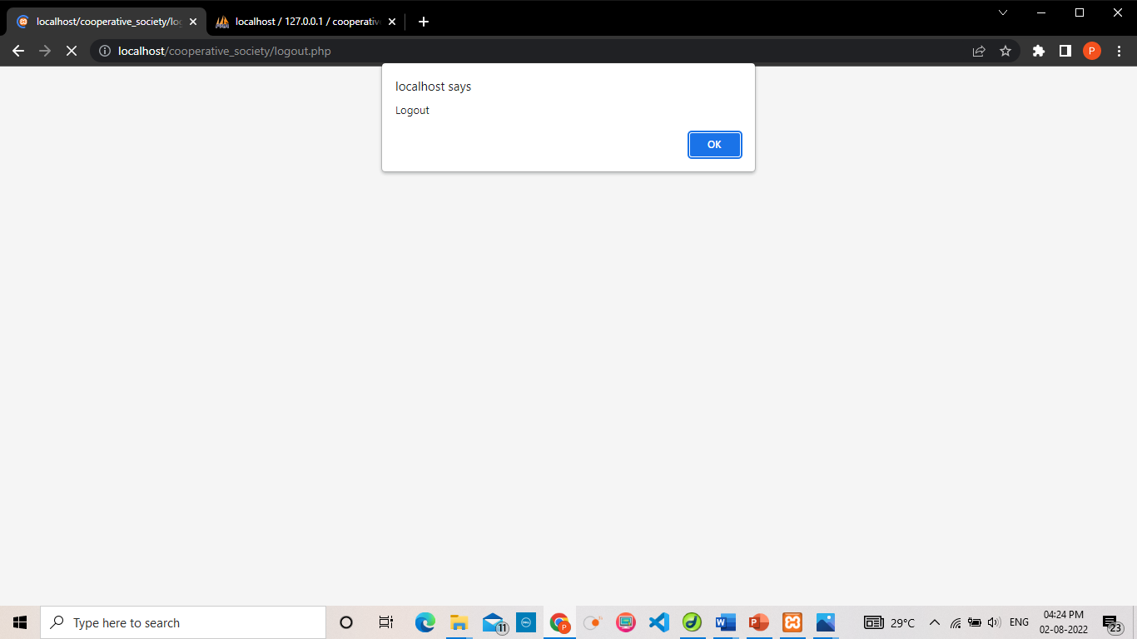

**17.CUSTOMER PAGE:**

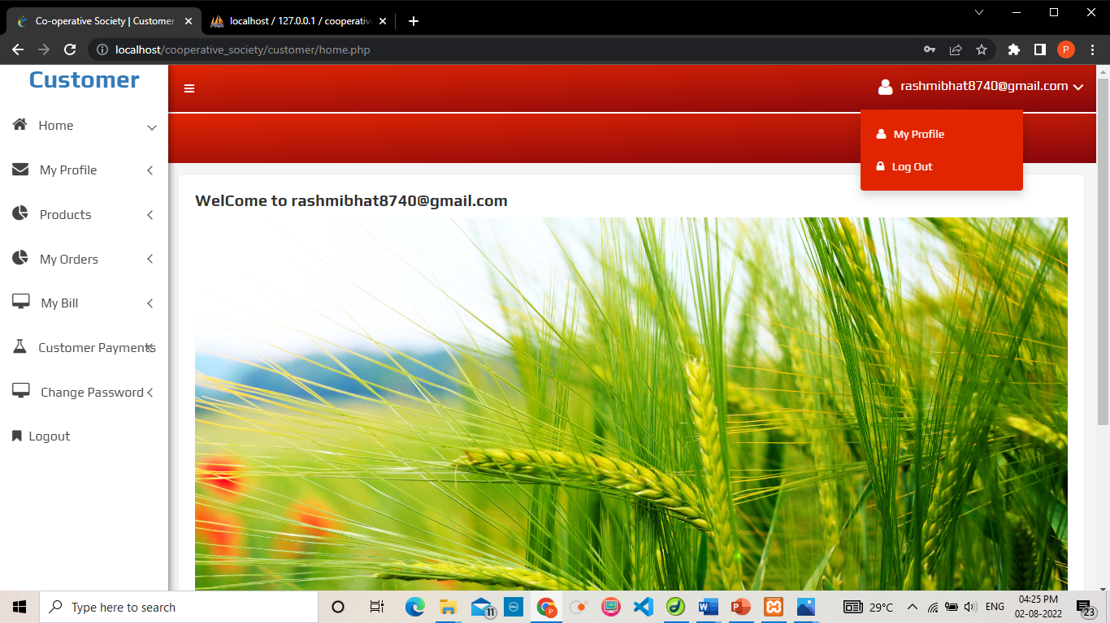

**18.CUSTOMER ORDER:**

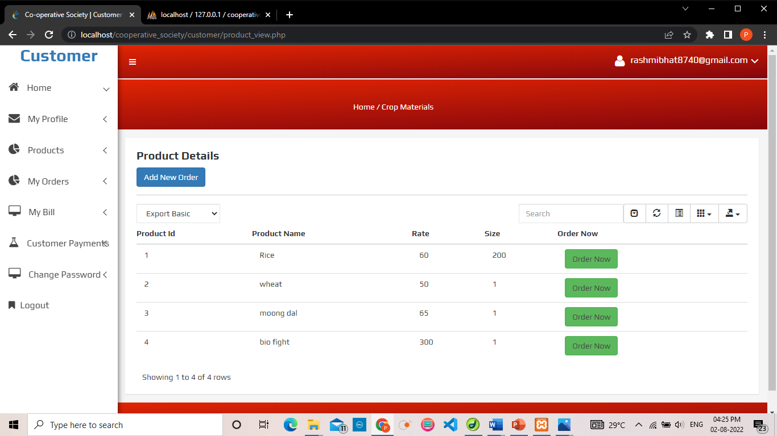

CODE

**Source code**

**1. Login & Registration**

<!--Author: W3layouts

Author URL: http://w3layouts.com

License: Creative Commons Attribution 3.0 Unported

License URL: http://creativecommons.org/licenses/by/3.0/

-->

<!DOCTYPE HTML>

<html lang="zxx">

<head>

<title>login</title>

<!-- Meta tag Keywords -->

<meta name="viewport" content="width=device-width, initial-scale=1">

<meta charset="UTF-8" />

<meta name="keywords" content="Triple Forms Responsive Widget,Login form widgets, Sign up Web forms , Login signup Responsive web form,Flat Pricing table,Flat Drop downs,Registration Forms,News letter Forms,Elements" />

<script>

addEventListener("load", function () {

setTimeout(hideURLbar, 0);

}, false);

function hideURLbar() {

window.scrollTo(0, 1);

}

</script>

<!-- Meta tag Keywords -->

<!-- css files -->

<link rel="stylesheet" href="css/style.css" type="text/css" media="all" />

<!-- Style-CSS -->

<link href="css/font-awesome.min.css" rel="stylesheet">

<!-- Font-Awesome-Icons-CSS -->

<!-- //css files -->

<!-- web-fonts -->

<link href="//fonts.googleapis.com/css?family=Roboto:100,100i,300,300i,400,400i,500,500i,700,700i,900,900i&amp;subset=cyrillic,cyrillic-ext,greek,greek-ext"

rel="stylesheet">

<!-- //web-fonts -->

</head>

<body>

<div class="main-bg">

<!-- title -->

<h1>Co-Operative Society </h1>

<!-- //title -->

<div class="sub-main-w3">

<div class="image-style">

</div>

<!-- vertical tabs -->

<div class="vertical-tab">

<div id="section1" class="section-w3ls">

<input type="radio" name="sections" id="option1" checked>

<label for="option1" class="icon-left-w3pvt"><span class="fa fa-user-circle" aria-hidden="true"></span>Login</label>

<article>

<form action="logcheck.php" method="post">

<h3 class="legend">Login Here</h3>

<div class="input">

<span class="fa fa-envelope-o" aria-hidden="true"></span>

<input type="email" placeholder="Email" name="username" required />

</div>

<div class="input">

<span class="fa fa-key" aria-hidden="true"></span>

<input type="password" placeholder="Password" name="password" minlength="6" maxlength="14" required />

</div>

<button type="submit" class="btn submit">Login</button>

</form>

</article>

</div>

<div id="section2" class="section-w3ls">

<input type="radio" name="sections" id="option2">

<label for="option2" class="icon-left-w3pvt"><span class="fa fa-pencil-square" aria-hidden="true"></span>Register</label>

<article>

<?php include('val.php');?>

<form action="customer_details_insert.php" id="formID" method="post">

<h3 class="legend">Register Here</h3>

<div class="input">

<span class="fa fa-user-o" aria-hidden="true"></span>

<input type="text" placeholder="Name" class="validate[required]" name="cn" required />

</div>

<div class="input">

<span class="fa fa-user-o" aria-hidden="true"></span>

<input type="text" placeholder="Address" class="validate[required]" name="ca" required />

</div>

<div class="input">

<span class="fa fa-user-o" aria-hidden="true"></span>

<input type="text" placeholder="City" name="cc" class="validate[required]" required />

</div>

<div class="input">

<span class="fa fa-user-o" aria-hidden="true"></span>

<input type="text" placeholder="Contact Number" name="cnor" class="form-control validate[required,custom[mobile]]" />

</div>

<div class="input">

<span class="fa fa-user-o" aria-hidden="true"></span>

<input type="text" placeholder="Email ID" name="em" class="form-control validate[required,custom[email]]" required />

</div>

<div class="input">

<span class="fa fa-key" aria-hidden="true"></span>

<input type="password" placeholder="Password" name="password" minlength="6" maxlength="14" class="form-control validate[required]" required />

</div>

<div class="input">

<span class="fa fa-key" aria-hidden="true"></span>

<input type="password" placeholder="Confirm Password" minlength="6" maxlength="14" class="form-control validate[required]" name="cpassword" required />

</div>

<div class="input">

<span class="fa fa-key" aria-hidden="true"></span>

<select name="hint_qtn" required >

<option value="">Select a Security Question</option>

<option>Which is your fav color?</option>

<option>Which is your fav city?</option>

</select>

</div>

<div class="input">

<span class="fa fa-key" aria-hidden="true"></span>

<input type="password" placeholder="Hint Answer" name="hint_ans" required />

</div>

<button type="submit" class="btn submit">Register</button>

</form>

</article>

</div>

<div id="section3" class="section-w3ls">

<input type="radio" name="sections" id="option3">

<label for="option3" class="icon-left-w3pvt"><span class="fa fa-lock" aria-hidden="true"></span>Forgot Password?</label>

<article>

<form action="forgot_password1.php" method="post">

<h3 class="legend last">Forgot Password</h3>

<p class="para-style">Enter your email address below and we'll guide you to get password.</p>

<div class="input">

<span class="fa fa-envelope-o" aria-hidden="true"></span>

<input type="email" placeholder="Email" name="username" required />

</div>

<button type="submit" class="btn submit last-btn">Retreive Password</button>

</form>

</article>

</div>

</div>

<!-- //vertical tabs -->

<div class="clear"></div>

</div>

<!-- copyright -->

<div class="copyright">

<h2>&copy; 2022 Co-Operative Society| Designed and Developed by

<a href="http://w3layouts.com" target="_blank">Priyanka Hegde and Rashmi Bhat</a>

</h2>

</div>

<!-- //copyright -->

</div>

</body>

</html>

**2. Customer Order Details View**

<?php include('meta_tag.php'); ?>

<body>

<!--[if lt IE 8]>

<p class="browserupgrade">You are using an <strong>outdated</strong> browser. Please <a href="http://browsehappy.com/">upgrade your browser</a> to improve your experience.</p>

<![endif]-->

<?php include('sidebar.php'); ?>

<!-- Mobile Menu end -->

<div class="breadcome-area">

<div class="container-fluid">

<div class="row">

<div class="col-lg-12 col-md-12 col-sm-12 col-xs-12">

<div class="breadcome-list single-page-breadcome">

<div class="row">

<div class="col-lg-6 col-md-6 col-sm-6 col-xs-6">

</div>

<div class="col-lg-6 col-md-6 col-sm-6 col-xs-6">

<ul class="breadcome-menu">

<li><a href="#">Home</a> <span class="bread-slash">/</span>

</li>

<li><span class="bread-blod">Customer Order Details</span>

</li>

</ul>

</div>

</div>

</div>

</div>

</div>

</div>

</div>

</div>

<!-- Static Table Start -->

<div class="data-table-area mg-tb-15">

<div class="container-fluid">

<div class="row">

<div class="col-lg-12 col-md-12 col-sm-12 col-xs-12">

<a href="customer_order_details.php" class="btn btn-info">Add New Order </a><hr>

<div class="sparkline13-list">

<div class="sparkline13-hd">

<div class="main-sparkline13-hd">

<h1>Order Details <span class="table-project-n">Data</span> Table</h1>

</div>

</div>

<div class="sparkline13-graph">

<div class="datatable-dashv1-list custom-datatable-overright">

<div id="toolbar">

<select class="form-control">

<option value="">Export Basic</option>

<option value="all">Export All</option>

<option value="selected">Export Selected</option>

</select>

</div>

<table id="table" data-toggle="table" data-pagination="true" data-search="true" data-show-columns="true" data-show-pagination-switch="true" data-show-refresh="true" data-key-events="true" data-show-toggle="true" data-resizable="true" data-cookie="true"

data-cookie-id-table="saveId" data-show-export="true" data-click-to-select="true" data-toolbar="#toolbar">

<thead>

<tr>

<th width="86">Order ID </th>

<th width="107">Customer Name </th>

<th width="101">Product Name </th>

<th width="77">Quantity</th>

<th width="140">Order Date </th>

<th width="93">Order Status</th>

<!-- <th width="93">Confirm</th>

<th width="93">Not Confirm</th>

<th width="102">Cancel</th> -->

</tr>

</thead>

<tbody>

<?php

include('database.php');

$uname=$_SESSION['uname'];

$sql="select * from customer_order_details cod,customer_details cd , products j where cod.customer_id=cd.customer_id and j.product_id=cod.product_id and cd.email='$uname'";

$res=(mysqli_query($conn,$sql));

while($row=mysqli_fetch_array($res))

{

?>

<tr>

<td>&nbsp;<?php echo $row['order_id'];?></td>

<td>&nbsp;<?php echo $row['customer_name'];?></td>

<td>&nbsp;<?php echo $row['product_name'];?></td>

<td>&nbsp;<?php echo $row['quantity'];?></td>

<td>&nbsp;<?php echo $row['order_date'];?></td>

<td>&nbsp;<a href="#" <?php if($row['status']=='Pending') {?> class="btn btn-warning" <?php } ?>

<?php if($row['status']=='Confirmed') {?> class="btn btn-success" <?php } ?>

<?php if($row['status']=='No Stock') {?> class="btn btn-danger" <?php } ?>

>

<?php echo $row['status'];?></a></td>

<!-- td><a href="customer_order_details_confirm.php?id=<?php echo $row['order_id'];?>&qnt=<?php echo $row['quantity'];?>&contact_no=<?php echo $row['contact_number']; ?>&jaggery_stock=<?php echo $row['jaggery_stock']; ?>&jaggery_id=<?php echo $row['jaggery_id']; ?>" onClick="return confirm('Are you sure to confirm?')" class="btn btn-primary">Confirm</a>&nbsp;</td>

<td><a href="customer_order_details_nostock.php?id=<?php echo $row['order_id'];?>" onClick="return confirm('Are you sure to No Stock?')" class="btn btn-primary">No&nbsp;Stock</a>&nbsp;</td>

<td><a href="customer_order_details_delete.php?id=<?php echo $row['order_id'];?>" onClick="return confirm('Are you sure to delete?')" class="btn btn-danger">Delete</a>&nbsp;</td> -->

</tr>

<?php

}

?>

</tbody>

</table>

</div>

</div>

</div>

</div>

</div>

</div>

</div>

<!-- Static Table End -->

<?php include('footer.php'); ?>

<!-- data table JS

============================================ -->

<script src="js/data-table/bootstrap-table.js"></script>

<script src="js/data-table/tableExport.js"></script>

<script src="js/data-table/data-table-active.js"></script>

<script src="js/data-table/bootstrap-table-editable.js"></script>

<script src="js/data-table/bootstrap-editable.js"></script>

<script src="js/data-table/bootstrap-table-resizable.js"></script>

<script src="js/data-table/colResizable-1.5.source.js"></script>

<script src="js/data-table/bootstrap-table-export.js"></script>

</html>

**2.1 Customer Order Details Confirm**

<?php

$order_id=$_REQUEST['id'];

$product_stock=$_REQUEST['product_stock'];

$product_id=$_REQUEST['product_id'];

$qnt=$_REQUEST['qnt'];

$contact_no=$_REQUEST['contact_no'];

$stock_p=$product_stock - $qnt;

include('database.php');

if($qnt<=$product_stock)

{

echo $sql="update customer_order_details set status='Confirmed' where order_id='$order_id'";

mysqli_query($conn,$sql);

$sql="update products set product_stock='$stock_p' where product_id='$product_id'";

mysqli_query($conn,$sql);

$msg1="Your Order is Confirmed";

$msg=str_replace(' ','+', $msg1);

?>

<script language="javascript1.2">

alert("Order Confirmed");

document.location="customer_order_details_view.php";

</script>

<?php

}

else

{

?>

<script language="javascript1.2">

alert("Out of Stock");

document.location="customer_order_details_view.php";

</script>

<?php

}

?>

**2.2 Customer Order Details No Stock**

<?php

$order_id=$_REQUEST['id'];

include('database.php');

$sql="update customer_order_details set status='No Stock' where order_id='$order_id'";

mysqli_query($conn,$sql);

?>

<script language="javascript1.2">

alert("No Stock Updated");

document.location="customer_order_details_view.php";

</script>

**SYSTEM TESTING**

**Testing: -**

**Introduction:**

The philosophy behind testing is to find bugs. The common view of testing Is that there are no errors in a program. However it is virtually impossible to prove that no program will be free and clear of errors. Therefore the most useful approach and practical approach is with the understanding that testing is the program fail.

Executing a program in a simulated environment performs verification. It is sometimes called Alpha Testing. Validation is the process of using the software in a live environment in order to find errors. It can be called as Beta Testing.

System testing is the stage of implementation, which aims at ensuring that the system works accurately and efficiently before actual operation commences.

No program or system design is perfect; communication between the user and the designer is not always complete or clear, and time is usually short. The result is errors and more errors. The number and nature of errors in a design depend on several factors

* Communication between the user and the designer.
* The programmer’s ability to generate a code that reflects exactly
* The system specification.
* The time frame for the design

**Test Approaches:**

**White Box Testing:**

It is a software testing method in which the internal structure/design implementation of the item being tested is known to the tester.

In white box testing a tester usually a developer as well studies the implementation of a certain field on a web page determines all legal and illegal inputs and verifies the output against the expected out comes which is also determined by studying the implementation of the code.

White box testing method is applicable to the following levels of software testing :

**Unit Testing:**

Individual components are tested to ensure that they operate correctly. Each component is tested independently without other system components.

Ex. Checked for Login and Password with the table.

**Module Testing:**

Module is a collection of dependent components such as an object classes an abstract data type or some looser collection of procedures and functions. A module encapsulates related components so can be tested without other system modules.

Ex: Created Skills and Schedule module and check its proper working with some dummy values. This is checked independent of all other modules.

**Subsystem Testing:**

This phase involves testing collection of modules which have been integrated into subsystems. Subsystems may be independently designed and implemented. The most common problems which arise in the large software systems are subsystems interface mismatches. The subsystem test process should therefore concentrate on the detection of interface errors by rigorously exercising these interfaces.

Ex: Created separate web pages for User subsystem and these are checked without involvement of other subsystems such as Employer, Administrator.

**Testing Strategies:**

There are two general strategies for testing software. There are follows

**Client Needs Acceptance Testing**

**Requirements System Testing**

**Design Integration Testing**

**Coding Unit Testing**

**Code Testing:**

This examines the logic of the program. To follow this test, cases are developed such that every path of the program is tested.

**Specification testing:**

Specification testing examines the specifications starting what the program should do and how it should perform under various conditions. Then test cases are developed for each condition and combinations of conditions and to be submitted for processing.

**Testing Method Used:**

We have used Black Box Testing and Statistical testing. In Black Box Testing, we have given all possible types of inputs and seen for corresponding outputs and if not giving, code was corrected.

In **Statistical Testing**, we have checked for all variables whether they assigned values before using it, whether array bound correctly defined, whether looping statements terminating without going to infinite loop, whether function parameters are passed in order and about number of parameters etc. are checked successfully and found correct and everything working satisfactorily.

**System Testing:**

The subsystems are integrated to make up the entire system. The testing process is concerned with finding errors which result from unanticipated interactions between subsystems and system components. It is also concerned with validating that the system is functional and non-functional requirements.

Ex: Those all subsystems are integrated and checked for inter-dependency between the subsystems.

**Acceptance Testing:**

This is final stage in testing process before the system is tested for operational use. The system is tested with data supplied by the system procurer rather than simulated test data. Acceptance testing may reveal errors and omissions in the systems requirements definitions because the real data exercises the system in different phase from the test data.

**Test Cases and Results:**

1. **Input:** Blank Username or Password

**Expected O/P:**Invalid Username or Password

**Result:** Passed





**2)Input:** Invalid Username or Password

**Expected O/P:** Invalid User.

**Result:** Passed

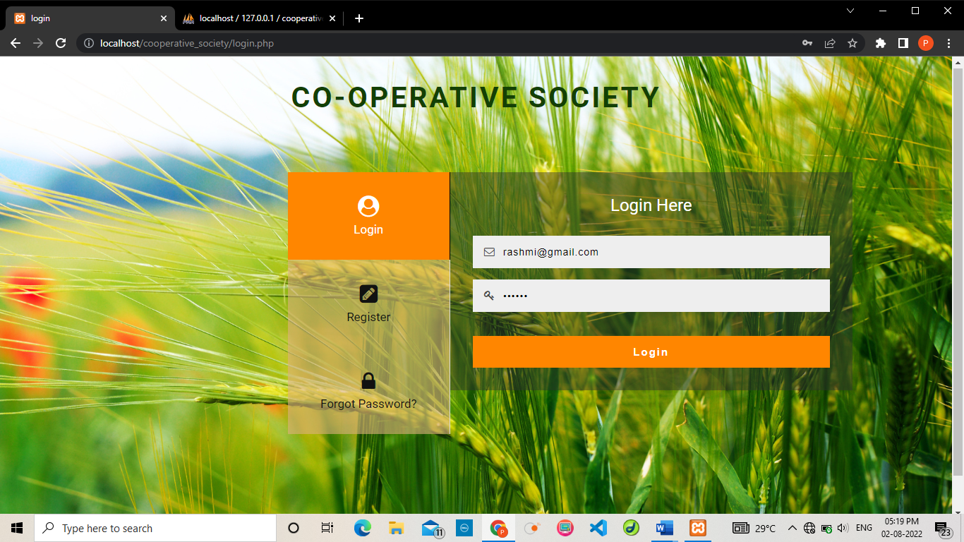

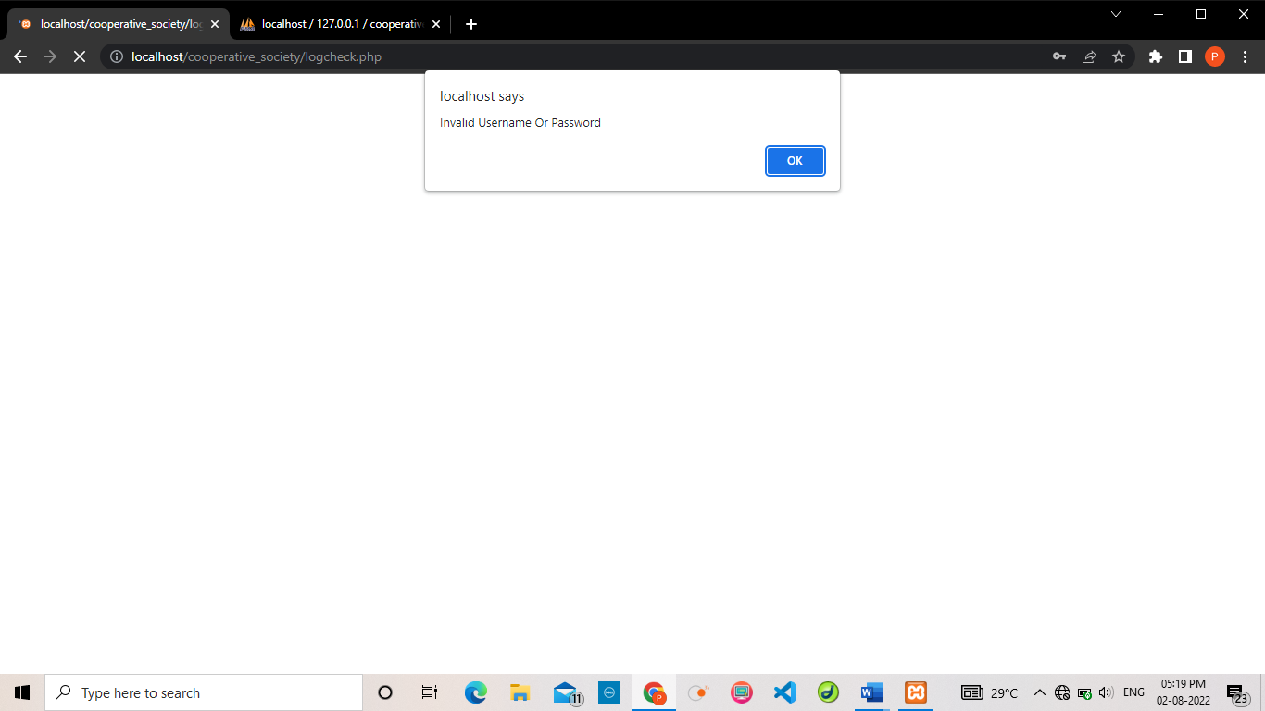

**3) Input:** In Email field if there no is @ symbol

**Expected O/P:** Invalid Email address

**Result:** Passed

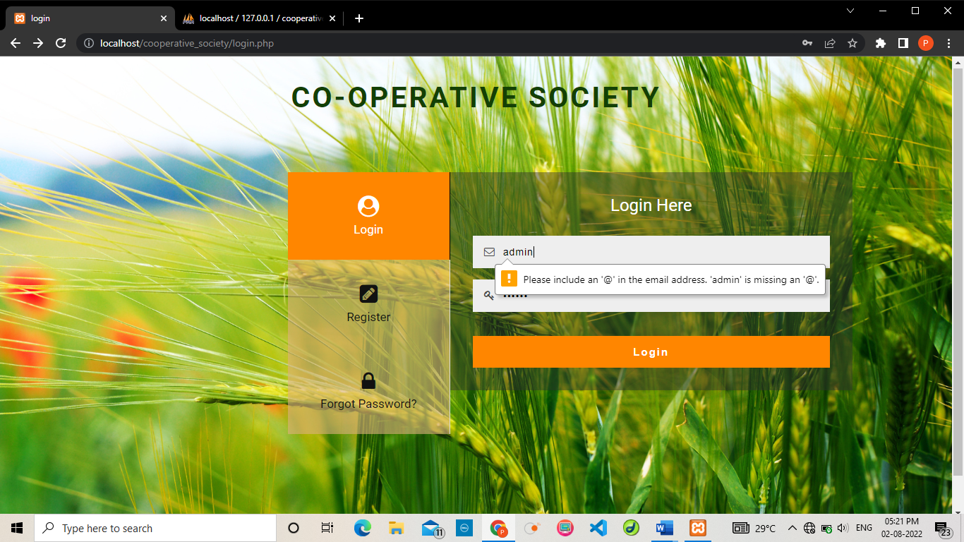

**4) Input:** In phone number if there if there less than 10 number

**Expected O/P:** Invalid mobile number

**Result:** Passed

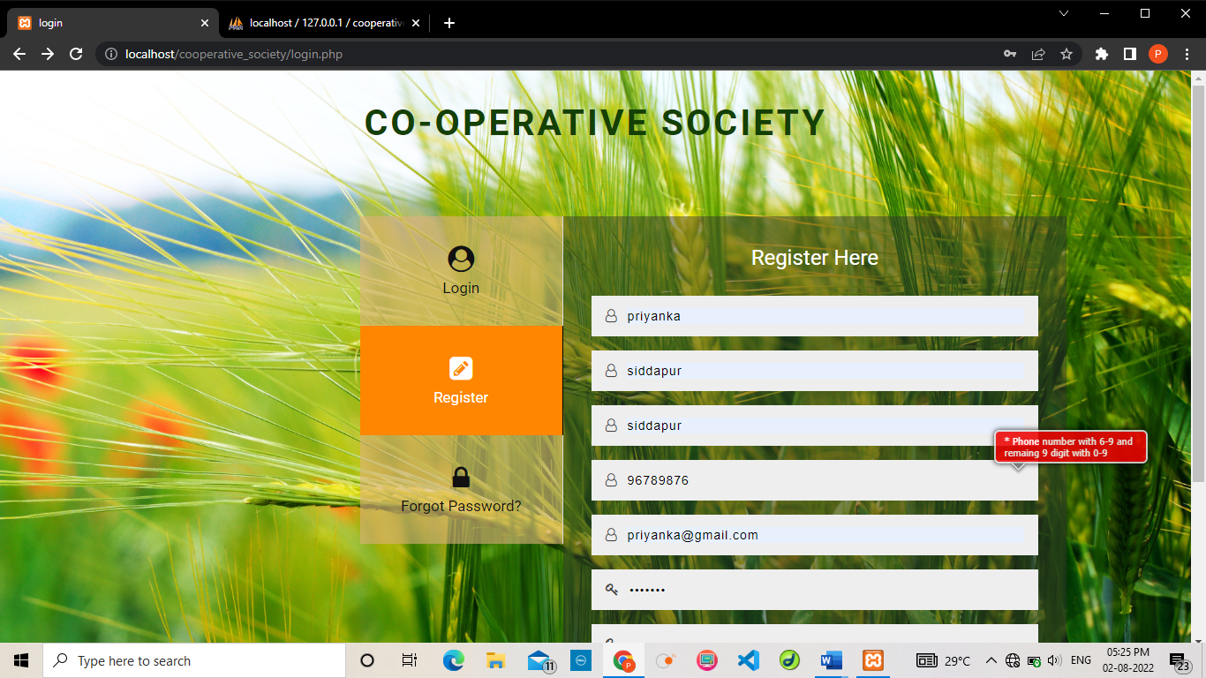

**CONCLUSION**

* Provide computerized system for maintaining records.
* More efficient & reliable.
* Less time consuming and easy to use
* Huge data storage with less computer memory
* Avoid human errors & efforts for maintaining daily data
* Avoid data manipulations
* Also avoids data inconsistency & redundancy

**Importance of the system:**

* Less manual work.
* Decreases the rate of errors.
* Less time consumption.
* It allows online ordering of products.

**Future Enhancement**

**FUTURE ENHANCEMENT**

The project made here is just to ensure that this product could be valid in today real challenging world. Here all the facilities are made and tested. Currently the system works for limited number of administrators to work. In near future it will be extended for many types of different standard policies so that efficiency can be improved.

We can provide the following features such as,

* mobile application can be developed.
* bar code scanning can be provided.
* Home delivery can be provided.
* Online bill payment

**LIMITATIONS**

* Live tracking of order is not possible.
* Bar code scanning is not provided.
* There is no online payment facility.

**BIBLIOGRAPHY AND REFERENCE**

**Text Books: Author**

* Software Engineering Ian Sommerville.
* Information system Analysis and V Rajaraman.

Design

* Database Management Systems, Navathe.
* IEEE SRS Format.

## Websites

* <http://www.hotscripts.com/category>[/php/](http://www.hotscripts.com/category/php/) for Php
* <http://en.wikipedia.org/wiki/PHP>for Php.
* <http://www.mysql.com/click.php?e=35050>for MySQL.